Welcome!
Date
Name
Spouse
Address
City
State Zip _________
Email

Please Contact By
❑ Card  Phone  Visit

Telephone Best Time to Call
Home ______________
Work ______________

Guest: First Time Second Time
Are you a church member: yes no
Church
City, State

Circle Appropriate Age/Grade Group(s)
Preschool: Ages: B-1 2-3 4-5
Children: Grades: K 1 2 3 4 5 6
Youth: Grades: 7 8 9 10 11 12
Adults: Ages:18-29 30s 40s 50s 60s+

How did you learn about our church?
Newspaper Friend Yellow Pages Mail
Other

I am a guest of:

New in the Community? Yes No
Names & ages of children at home

Weekly Service & Activity Schedule

May 7, 2017
9:15 a.m. New Commandment Kids
9:45 a.m. Sunday School
11:00 a.m. Worship Service
6:00 p.m. “The Burden of Self Reliance”

Week of May 7, 2017
Wednesday 6:30 pm………………..…Meal/Bible Study
Thursday 10:00 am……………..……Adult Fellowship
Friday 6:30 pm……………..……………..Men’s 42 Night
May
14…………………………………….…………..Mother’s Day
14…………………………………..New Commandment Kids
21…………………………..….Graduate Recognition Lunch
21……………………………………..…….Business Meeting
25…………………………………………….Adult Fellowship
28………………….…………………..Memorial Day Service

Independence Music Festival

Tonight @ 6:00 pm

Calvary Baptist Church
Brenham


If you have a graduate you would like to recognize at the Graduate Lunch on May 21 please let Brother David or Patti Radford know. High School, College, Trade School

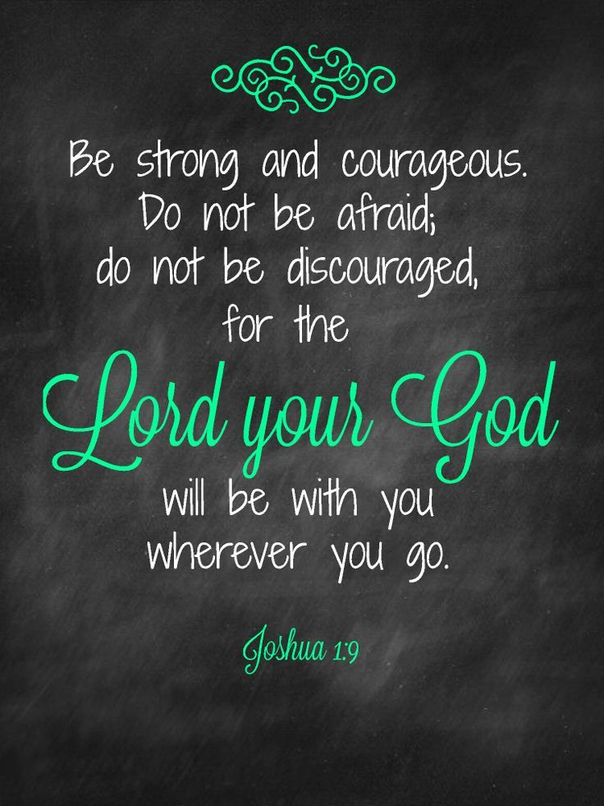

Knobbs Springs Baptist Church

May 7, 2017

Church Information:

KnobbsSpringsBC.com KnobbsSpringsBaptist@gmail.com

1662 CR 305, McDade, Texas 78650 512-273-2743

David Atwood, Pastor Cell 512-470-5098

Patti Radford, Office Manager Cell 512-968-7821

